**IoT - Individual Project 6.04.2025**

**Table of contents**

1. Instructions
2. Components
3. Image of setup
4. Methodology
5. Working Principle
6. Results
7. Challenges
8. Code
9. Outputs
10. ThingSpeak
11. Schematics
12. Youtube video link

**1.Instructions**

Connect a BH1750 and a BMP280 via I2C. Visualize the measurements on an online  
dashboard (e.g. ThingSpeak or InfluxDB or Grafana).  
Create inputs (GPIO) to select pre-defined settings for temperature and lux values; show  
these values on the dashboard.  
Create outputs (GPIO) to control light (e.g. by PWM LED or by opening/closing shades with  
stepper motor) and temperature (e.g. by adjusting current through a resistor in thermal  
contact with the sensor).  
Close the loop: automatically adjust light and temperature to the settings

**2.Components**

The components that I used in this project are as follows;

1. Orange Pi 3 lts

2. BH1750

3. BMP280

4. ULN 2003

5. Stepper motor

6.  LEDs (2)

7. Resistors (3)

8. Push button

9. Jumper cables

10. Ethernet and ethernet to pc adapter

11.Usb c power supply

12.Bread board

**3.Image of setup**

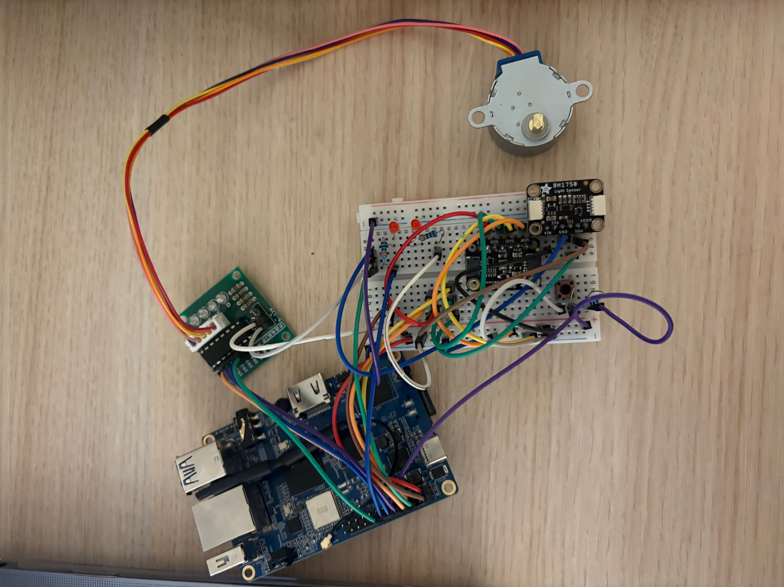

**4.Methodology**

1. At first, I flashed the SD card using the image provided on Canvas. Then, I inserted it into the Orange Pi, connected it to my PC via Ethernet, and powered it using a USB-C cable. I configured the IP address and connected it to Wi-Fi.
2. Following the setup guide from Canvas, I installed all the necessary libraries on the Orange Pi and got Python up and running.
3. Once the Orange Pi was fully set up, I moved on to the hardware components.
4. I connected my sensors—a BH1750 light sensor and a BMP280 temperature/pressure sensor—on a breadboard using jumper wires. I connected VIN to VIN, GND to GND, SCL to SCK, and SDA to SDI. Then, I connected them to the Orange Pi jumper cables: SDA and SCL.
5. I added two LED lights to the breadboard, each with their assigned resistor. I wired them with jumper cables and connected them to the Orange P.
6. I also added a push button with a resistor, wired it properly, and connected it to pin 22 of the Orange Pi.
7. Next, I assembled the ULN2003 motor driver and the stepper motor, connecting to the Orange Pi using jumper cables.
8. I wired the breadboard for power: a cable connected the breadboard's positive rail to pin 1 of the Orange Pi, and a cable connected the negative rail to pin 6. I also used another cable to link the negative rails on the breadboard. Additionally, I connected a wire from the VIN of the BH1750 to the positive rail and a wire from SCL to the negative.
9. Finally, I wired the push button: a wire from the resistor side of the button to the positive rail, and the other side to the negative.

After completing the hardware setup, I created a Python script in VS Code to control and run the system. Through trial and error, I refined the code to work as intended.

In my code, I integrated my ThingSpeak API key to visualize sensor data. I set it so that:

* If the lux value is above 200, LED B lights up.
* If the lux value is below 50, LED A lights up.
* If the temperature is above 19°C, the motor spins.

**5. Working Principle**  
The idea was to have LED B blink in daylight and LED A blink in darkness, indicating day and night respectively. The motor would spin when the temperature exceeded a level, simulating a basic cooling system like a fan. Additionally, a push button was added to terminate the program functioning like a Ctrl + C command.

**6. Results**  
LED B blinked in light, while LED A did the same in the dark. The motor performed full rotations when the temperature was high, and the push button shut everything down when pressed.

**7. Challenges**  
I encountered issues with configuring at first because of my mac computer, after solving that issue I also encountered with faulty components, which weren’t obvious until testing the full setup. I troubleshooted the code, only to discover defective sensors. Finding a reliable, all-in-one script was time-consuming..

**8.Code**

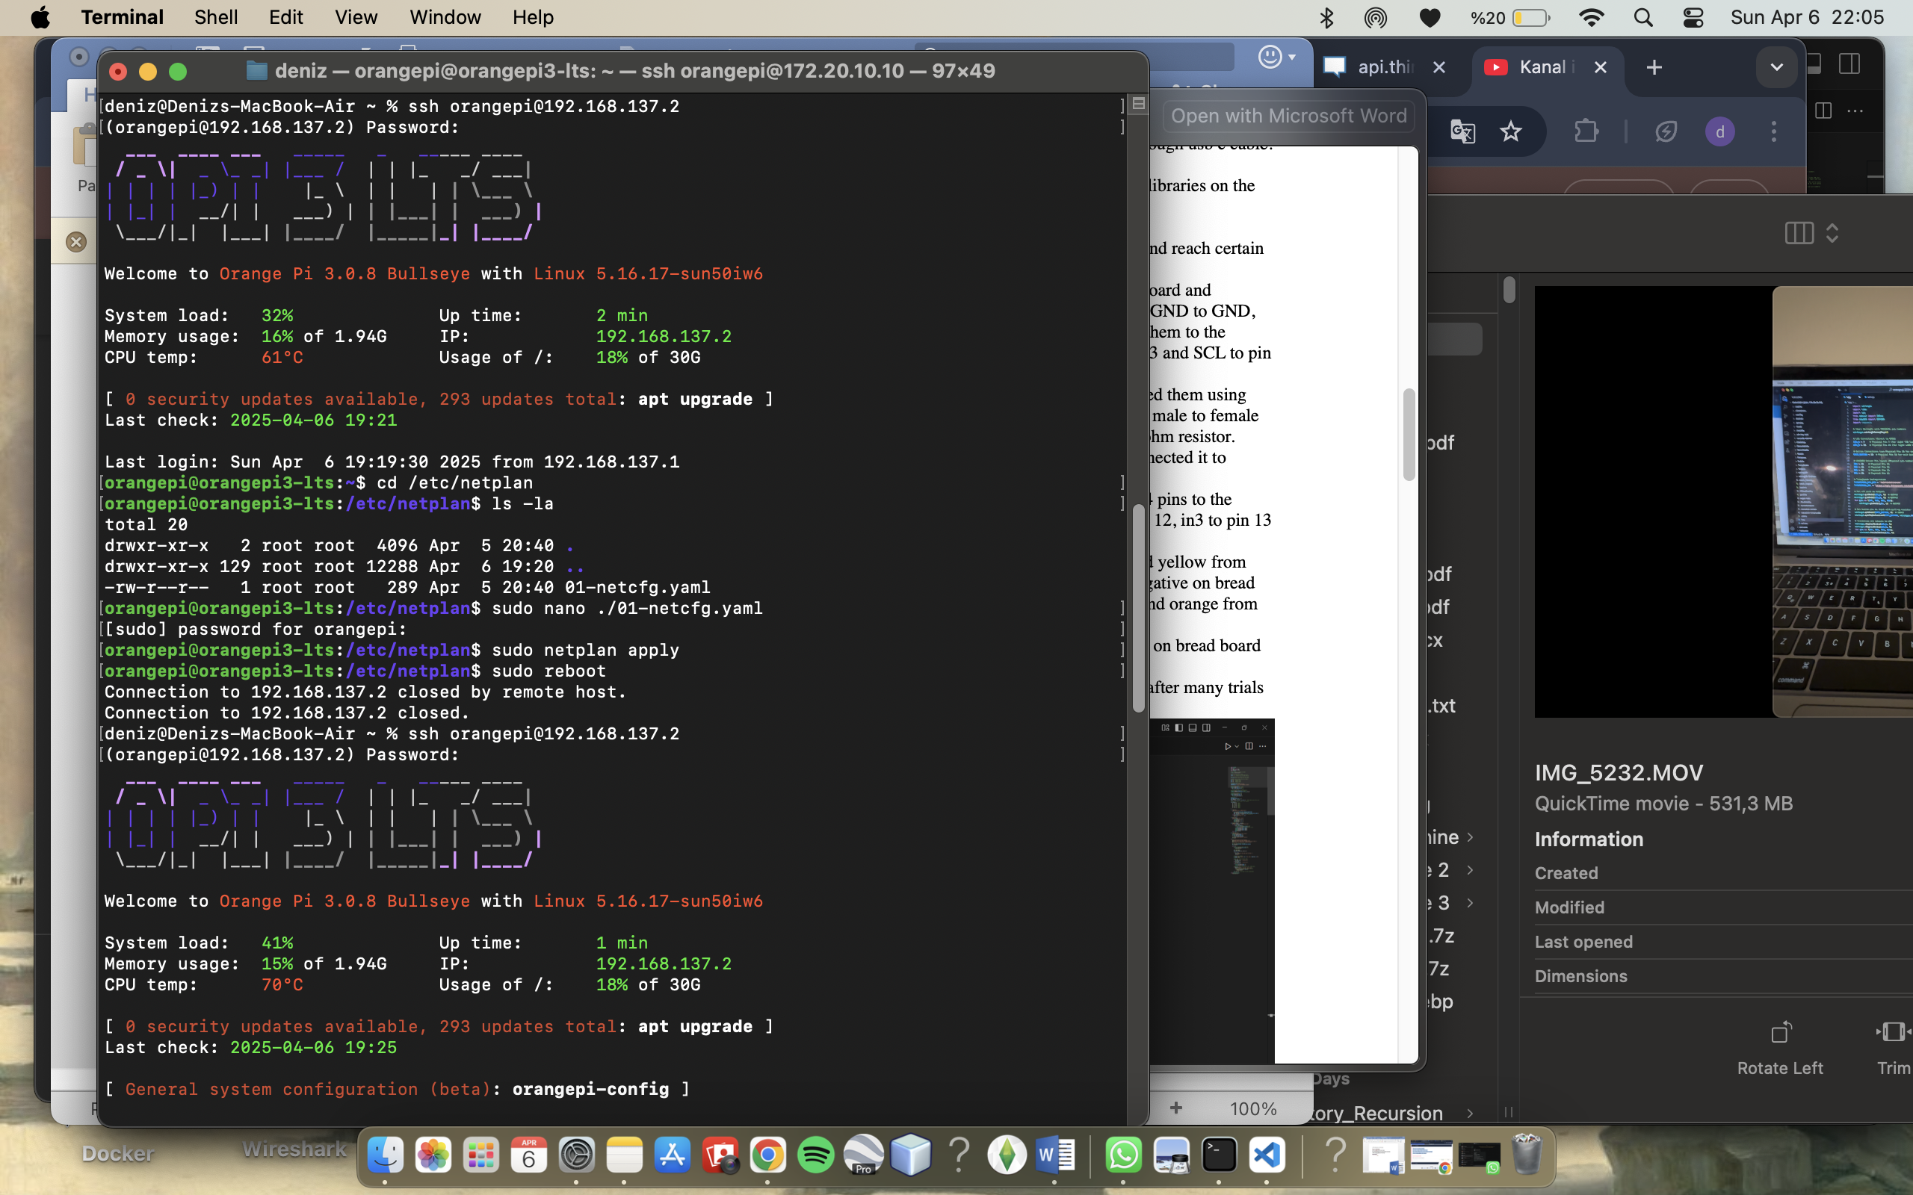

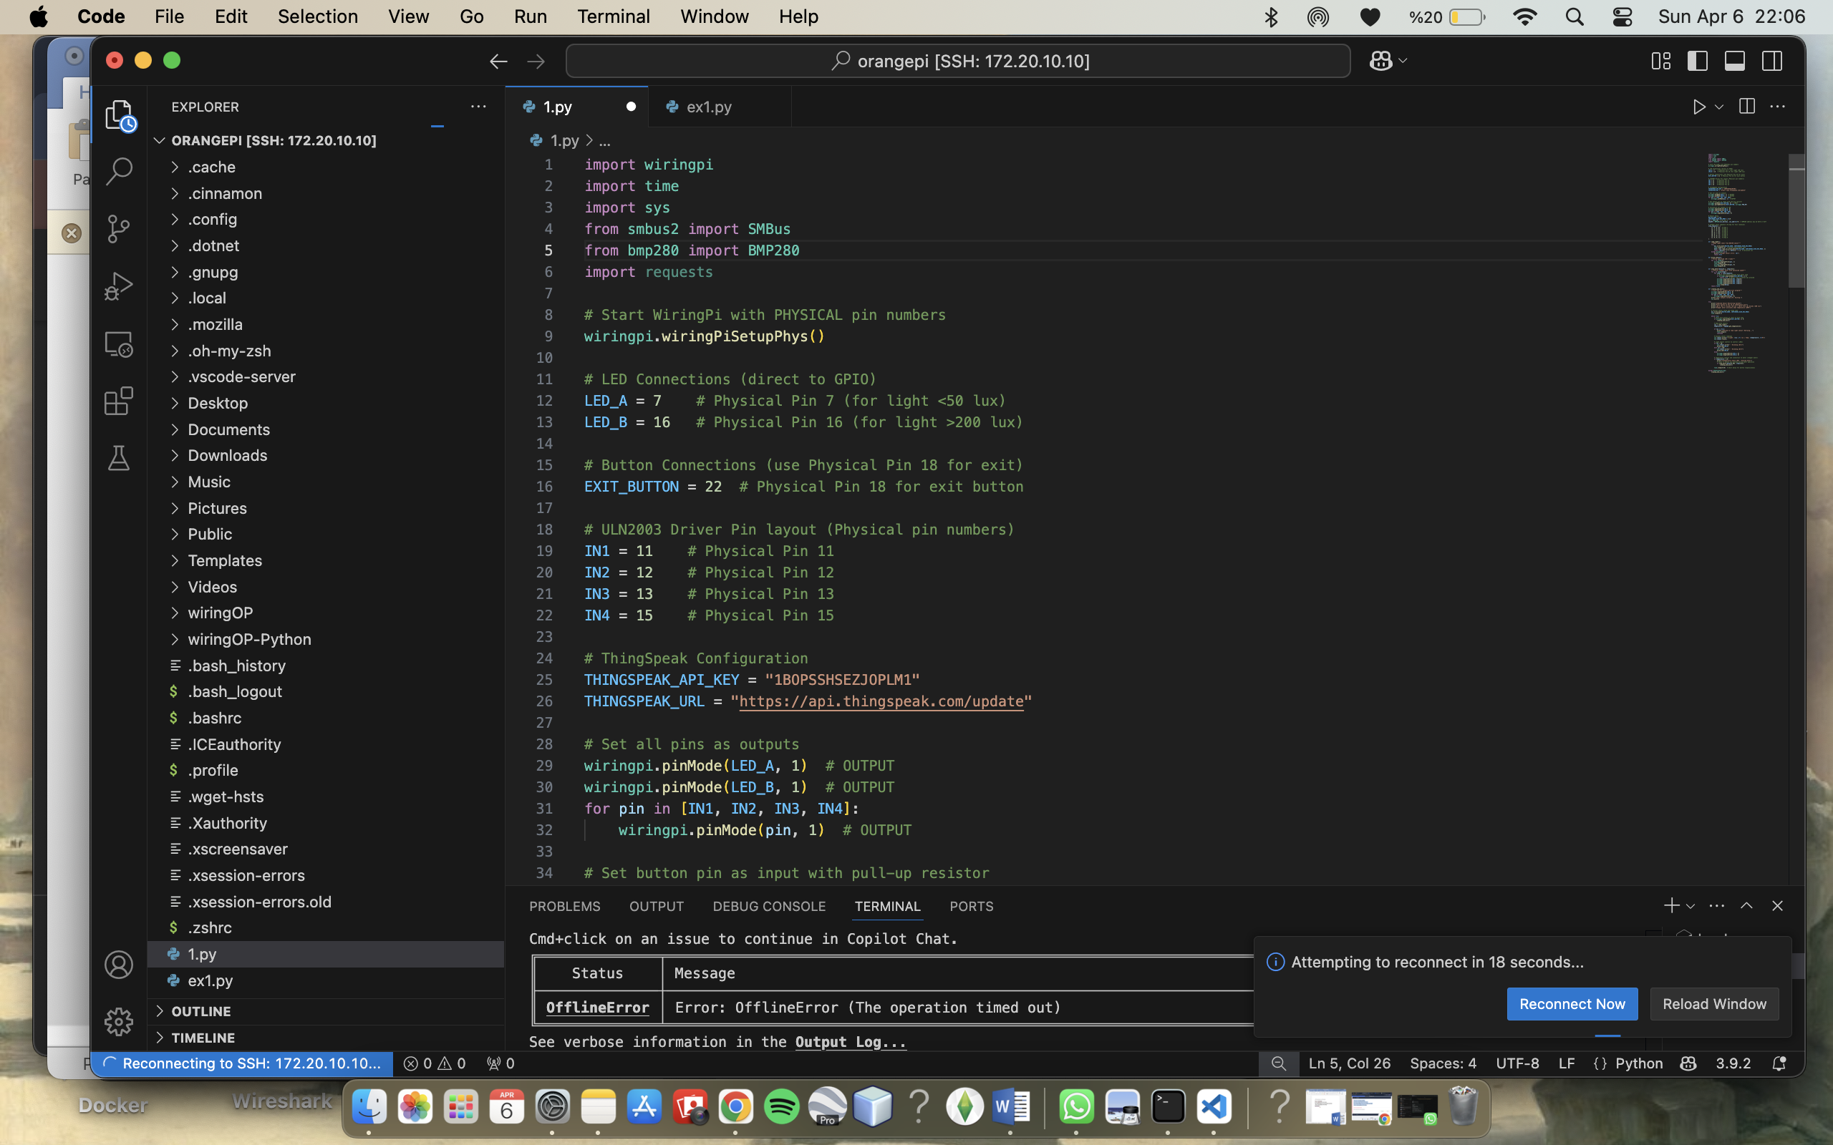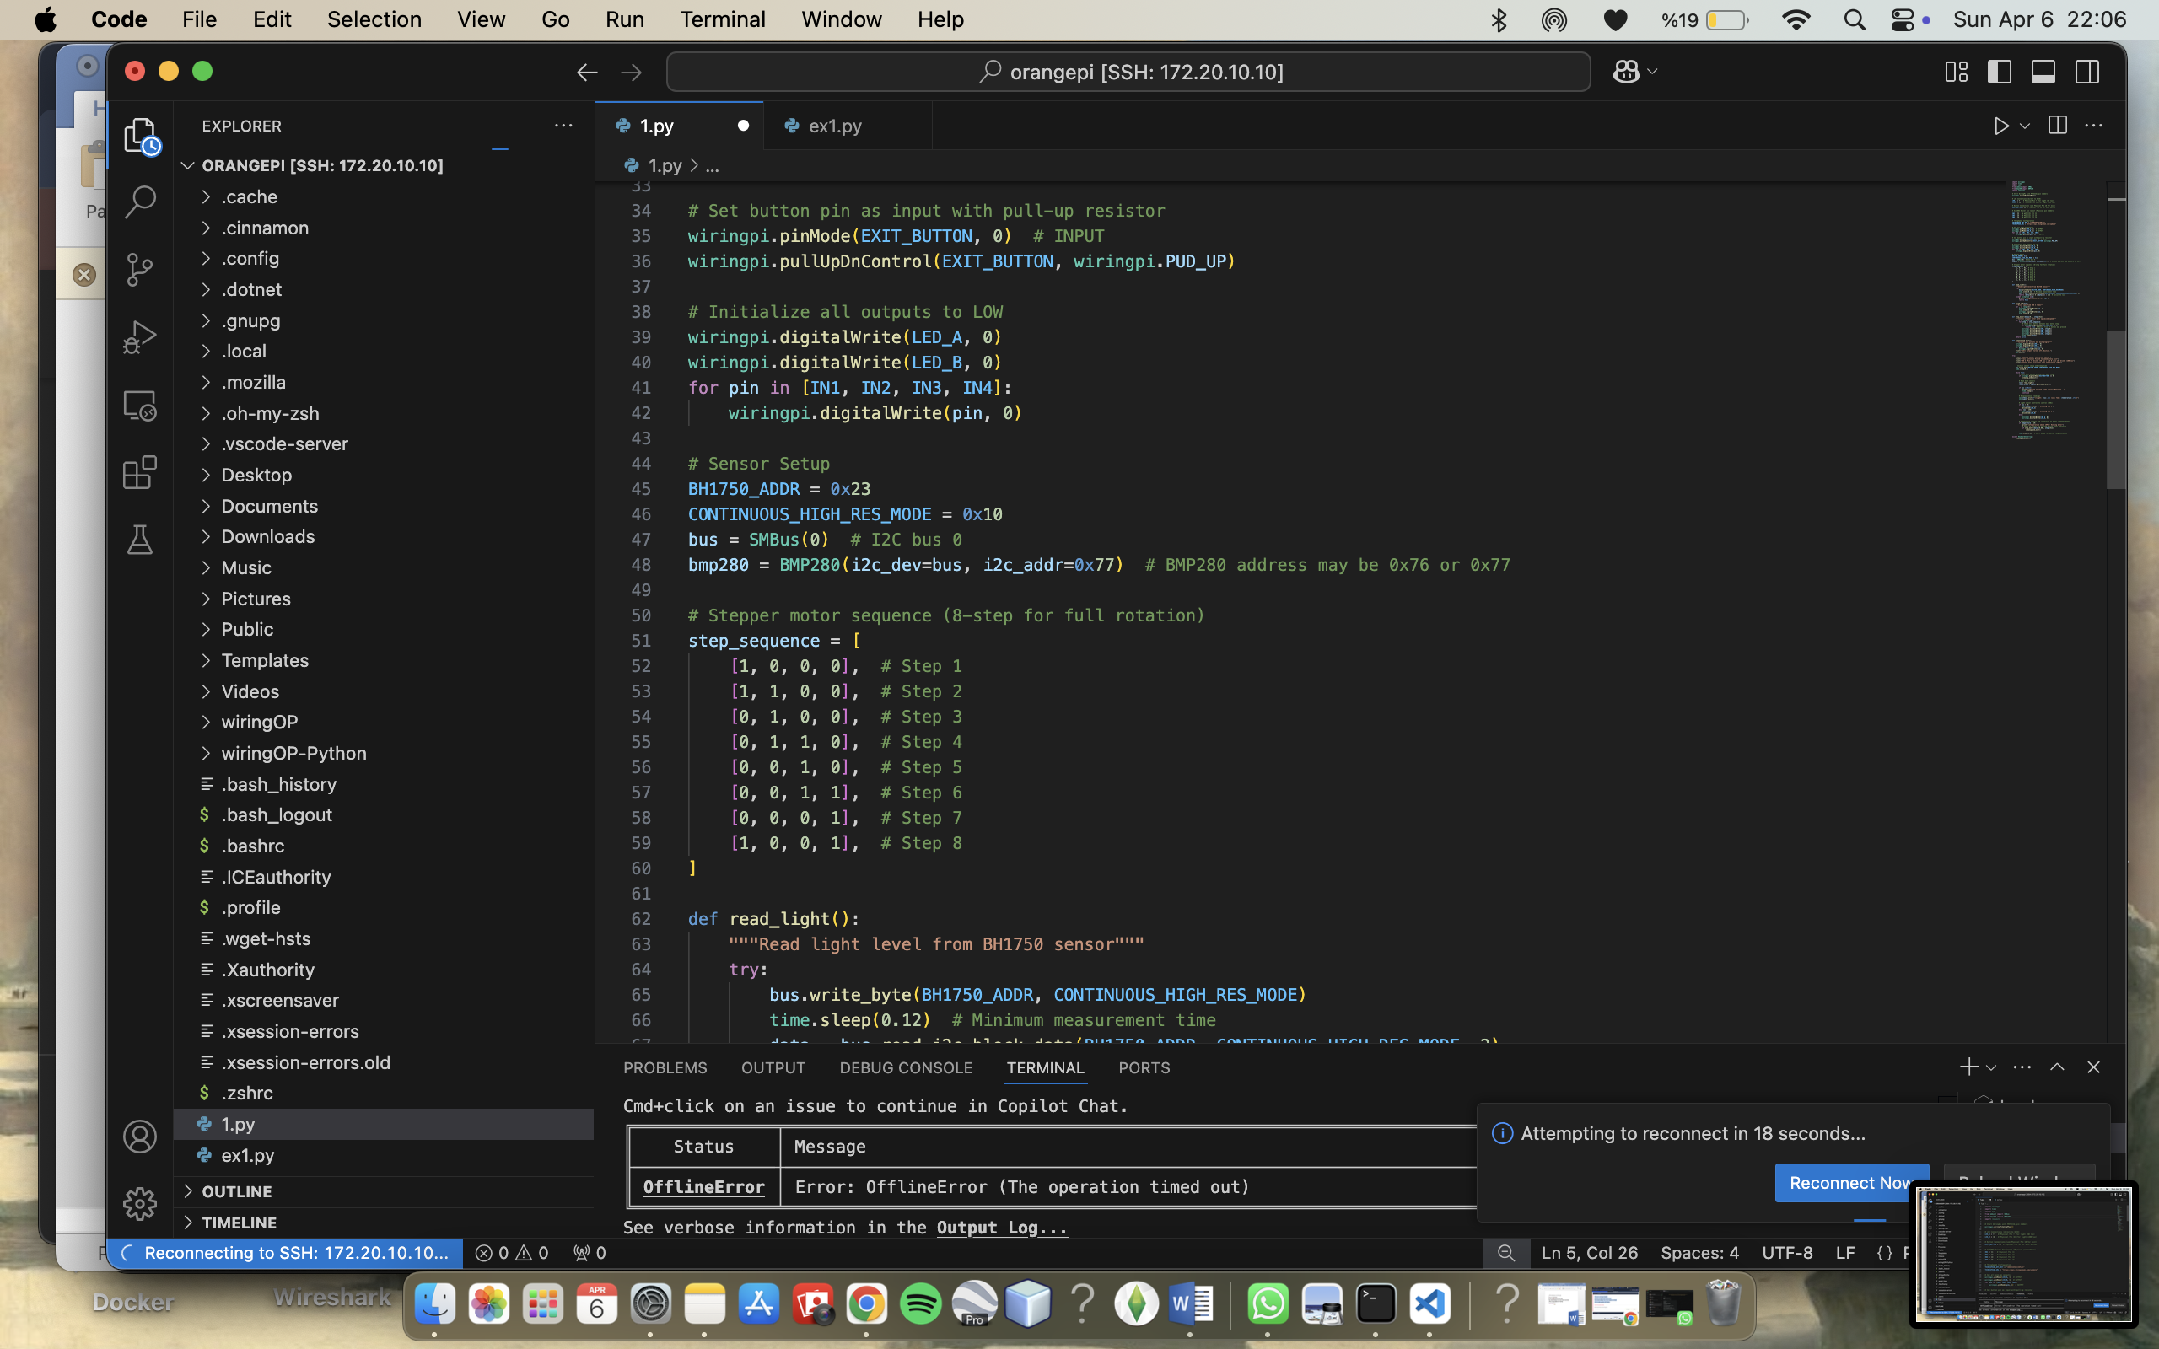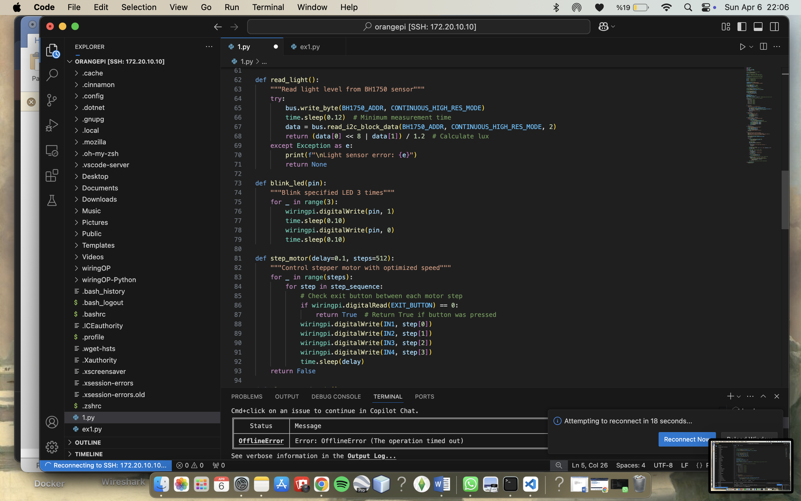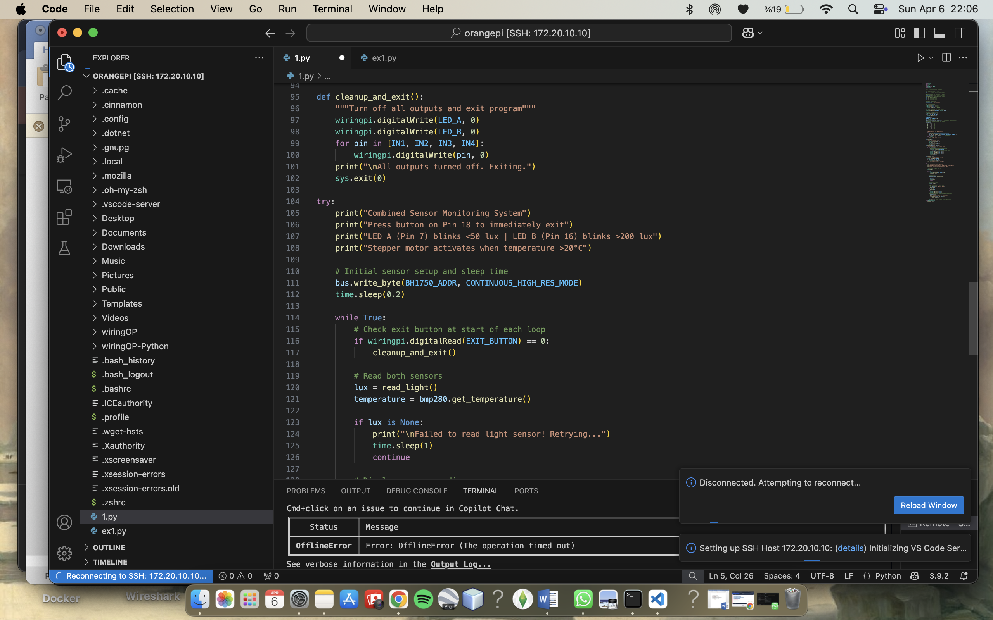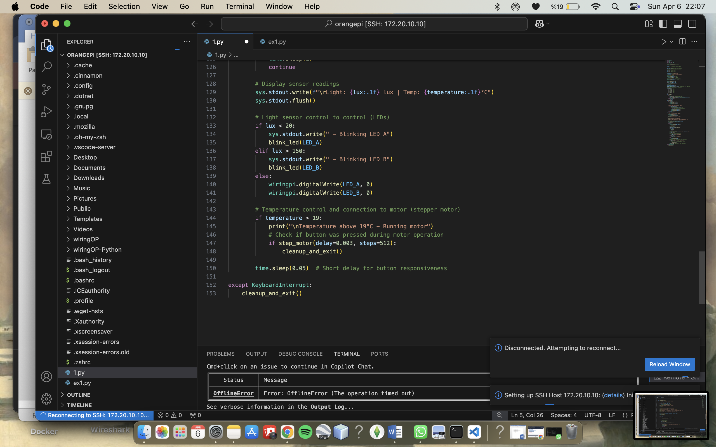

5.Outputs

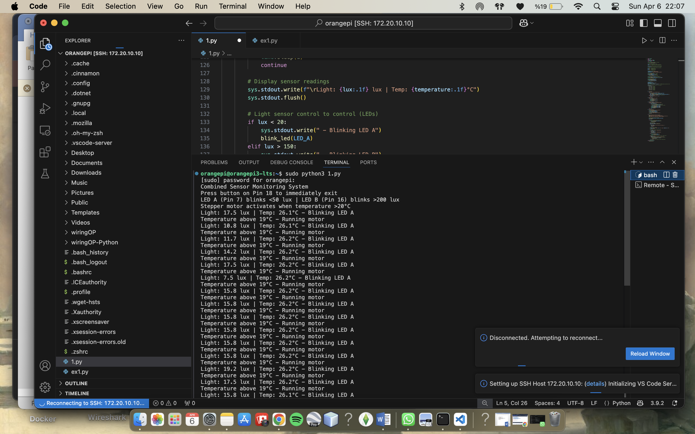

6.ThingSpeak

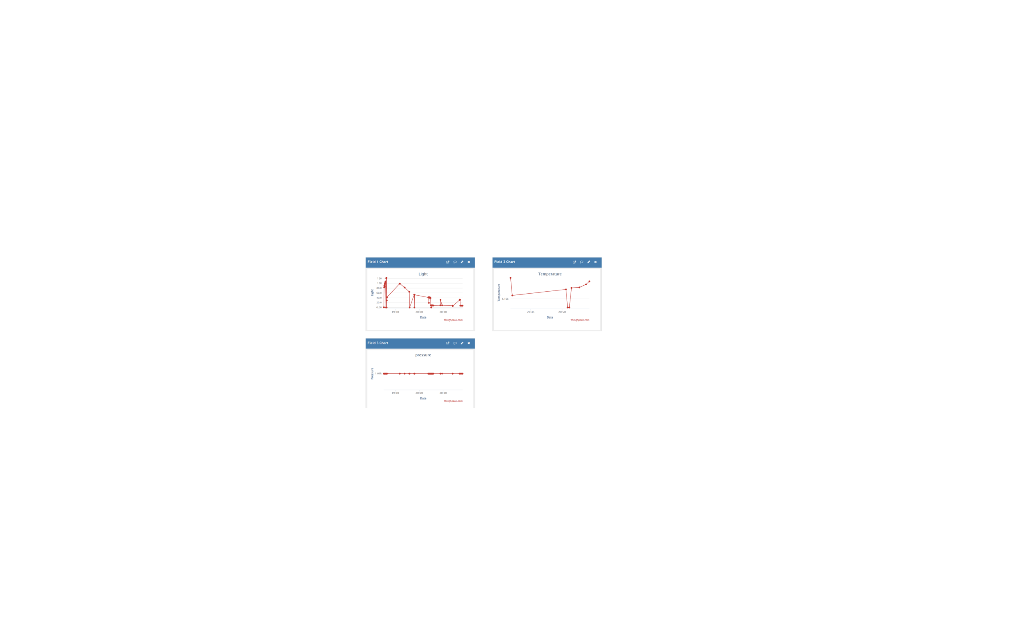

8. Youtube video link: [*https://youtu.be/h7lP05E0Lg4*](https://youtu.be/h7lP05E0Lg4)